## Power Bi project- Exhaustive analysis of indian

**Agriculture section using Power Bi**

* **First I install Power Bi desktop app in microsoft app**
* **Then I download “Exhaustive analysis of indian agriculture section” from whatsapp group**
* **Then download the data set and add it on the Power Bi desktop**
* **Now open Power Bi and click on blank report**
* 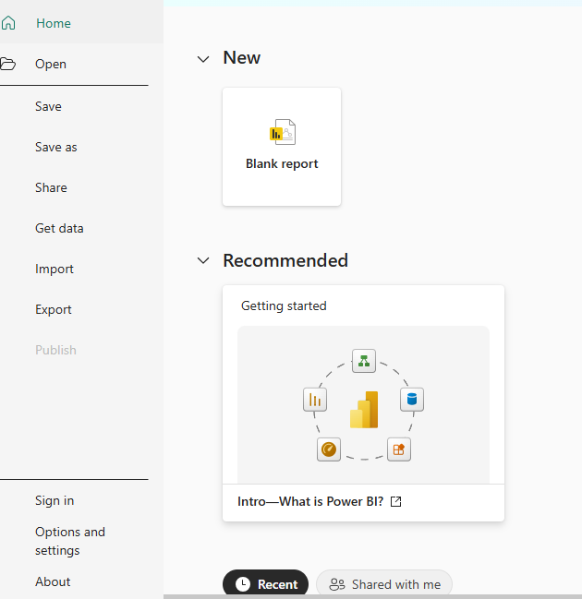
* **Then it opened like this:**
* 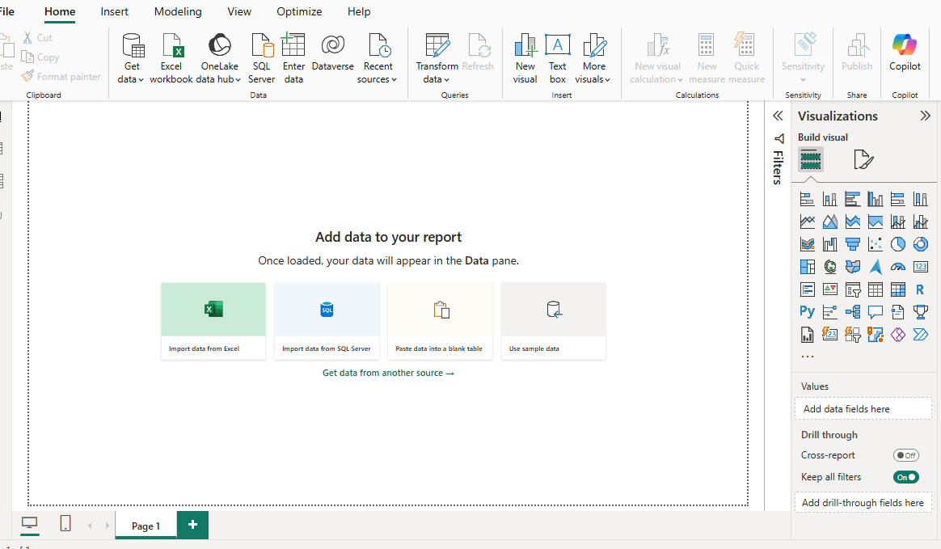
* **Then click on Text/CSV option.**
* **Then select the dataset on file explorer**
* **Then we get like this :**
* 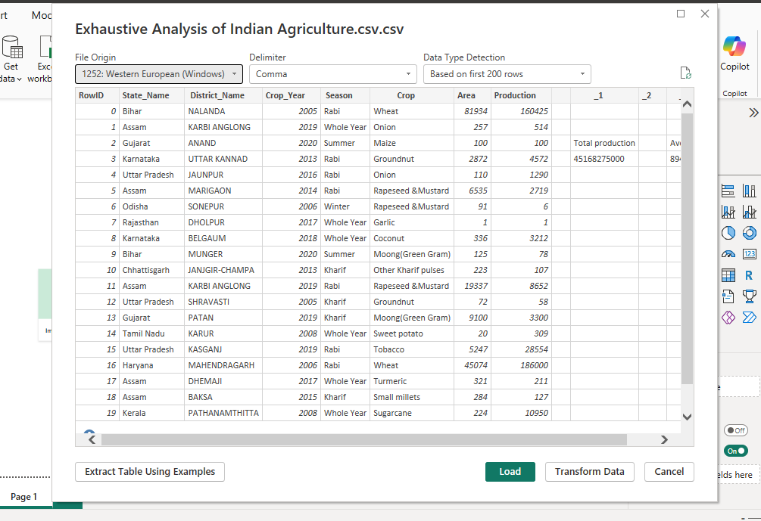
* **Now click on load button, then it shows like this:**
* 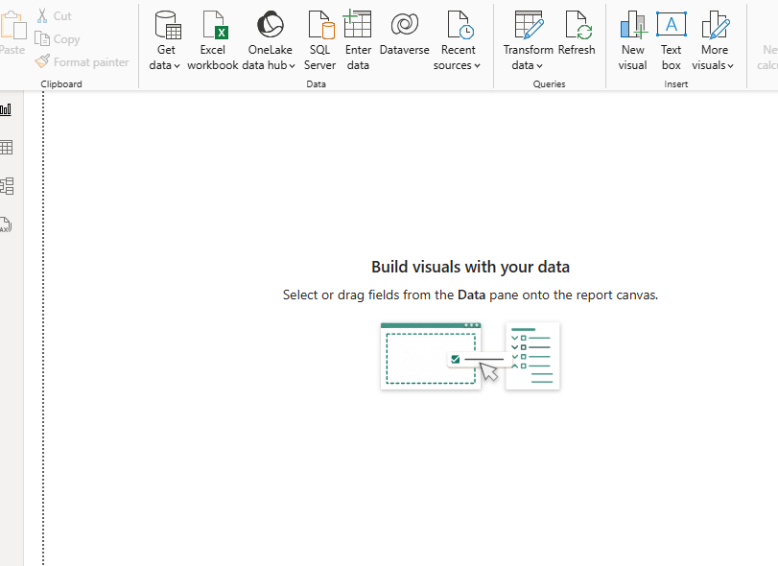
* **Now in report view we get visualization and in table view we see the actual data,**
* **And then remove the empty rows in the data set for creating relationship among them**
* 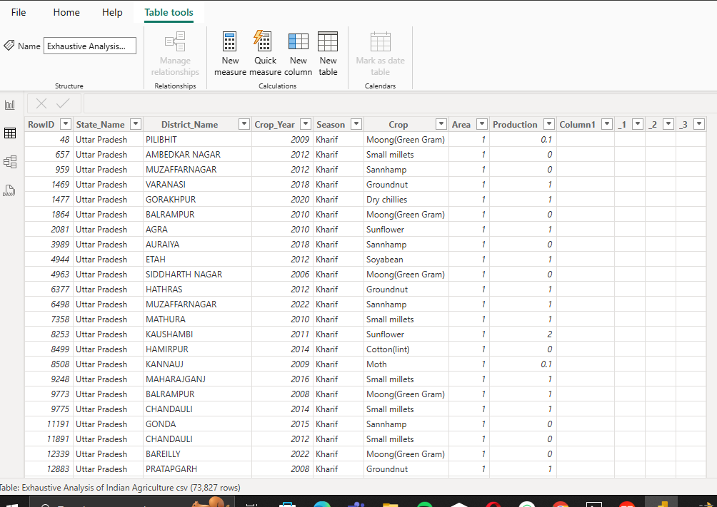
* **Now we can see how to transform data.**
* **So,now click on the Home in the above left corner(second option)**
* 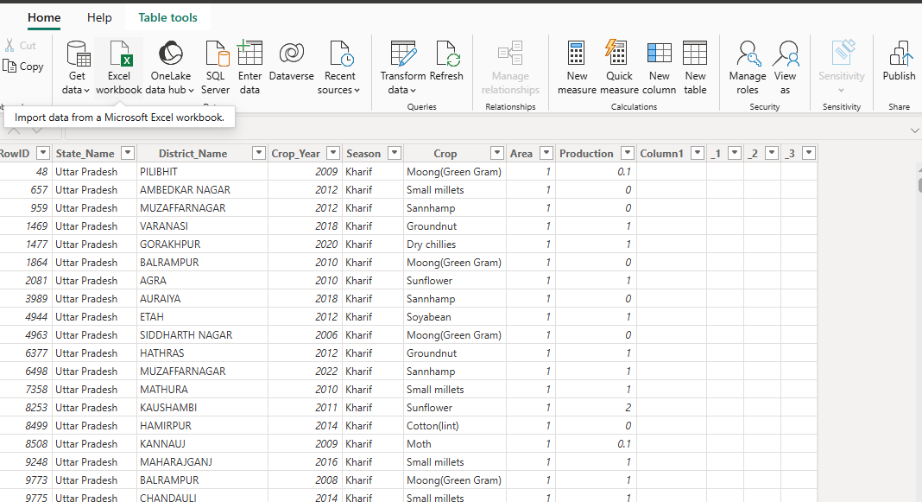
* **Now,click on transform data,**
* **Now it will go to Power Query Editor like this:**
* 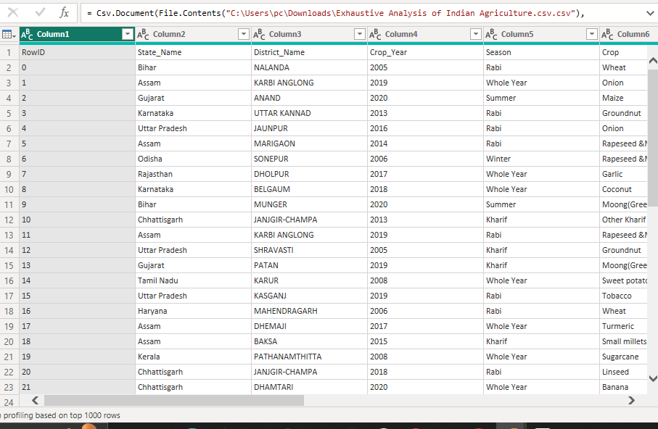
* **Then delete the empty rows in the dataset.**
* **Now,select view option and select column quality then see the errors and null values in the dataset**
* 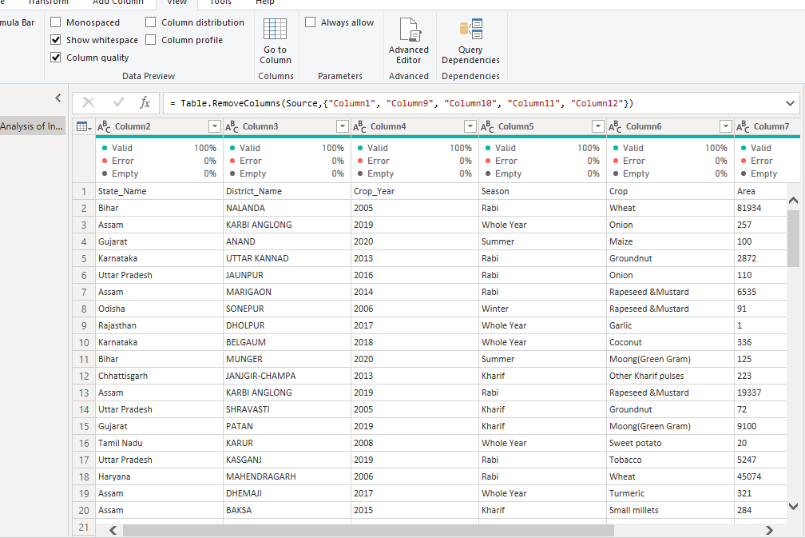
* **For removing rows and columns,split columns that we have so many options in the Home section**
* **To change the datatypes of the particular row ,just click on the abc(or)123 to change the datatypes.**
* **If we have any duplicates in the dataset then click on remove duplicates in the home section.**
* **To save the file click on the Click and Apply to save all the changes in Power query file.**
* **So it doesn’t show any Unneccesary files.**